|  |  |
| --- | --- |
| **Name:** Team Green |  |
| **Project:** Provisio |  |
| **Course:** CSD460 Capstone |  |
| **Description:** Test Plan for Six Functional Tests |  |
| **Date:** 04/09/2022 |  |
| **Version:** 1 |  |

**TABLE OF CONTENTS**

**Landing Page - Access** 2

**Landing Page - Slideshow** 2

**Login Page – Successful Login** 3

**Registration Page – Duplicate users** 4

**Registration Page - Passwords** 4

**Andrew & Jacob’s Test Plan:**

|  |  |  |  |  |
| --- | --- | --- | --- | --- |
| Test 1 | **Landing Page - Access** | | | |
|  | **Test Objective:** Functionality of Landing page | **Developer:**  **Date tested:** 2022/04/09 | **Peer tester:**  **Date tested:** 2022/04/09 | |
| **Step** | **Action** | **Expected results:** | **Developer pass/fail** | **Tester pass/fail** |
| 1 | Visit https://buwebdev.github.io/todo/ | URL is correct | yes | yes |
| 2 | Select field in “Task Form” and enter test task | Field is accessible and responds to input | yes | yes |
| 3 | Select “Add Task” button | Button is accessible and responds when clicked | yes | yes |
| 4 | Confirm new task correctly displayed in “Todo List” | Test task is now displayed in “Todo List” | yes | yes |
| **Comments** | ”Enter comment here”. | | | |

|  |  |  |  |  |
| --- | --- | --- | --- | --- |
| Test 2 | **Landing Page - Slideshow** | | | |
|  | **Test Objective: Test functionality of slideshow on the index page** | **Developer:**  **Date tested:** 2022/04/10 | **Peer tester:**  **Date tested:** 2022/04/10 | |
| **Step** | **Action** | **Expected results:** | **Developer pass/fail** | **Tester pass/fail** |
| 1 | Access the Provisio landing/home and have page load | Full page, along with 1st image content displayed center screen | yes | yes |
| 2 | Click the forward arrow to cycle through the slideshow of location images | Images should cycle through 3 images; after loading the 3rd image, clicking on the forward arrow again should reset the slideshow to the first image | yes | yes |
| 3 | Click the back arrow to make sure slideshow can cycle backwards through the images | Images should cycle backwards through the images; like the forward arrow, when arriving at the first image, clicking the back arrow should load the 3rd image in the slideshow | yes | yes |
| 4 | Confirm that clicking the dot markers below the slideshow will take the user to specific images in the list | Clicking the first, second, or third dot should load either the first, second, or third image, respectively | yes | <yes/no> |
| **Comments** | ”Enter comment here”. | | | |
|  |  | | | |

**Slideshow Test Plan:**

1. **Works**

1. **Works**

1. **Works**

1. **Works**

**Mitchell and Caleb’s Test Plan:**

|  |  |  |  |  |
| --- | --- | --- | --- | --- |
| Test 3 | **Login Page – Successful Login** | | | |
|  | **Test Objective:** Confirm profile icon works properly in header | **Developer:**  **Date tested:** 2022/04/09 | **Peer tester:**  **Date tested:** 2022/04/09 | |
| **Step** | **Action** | **Expected results:** | **Developer pass/fail** | **Tester pass/fail** |
| 1 | Login | Redirects to lobby | yes | yes |
| 2 | Profile icon appears in header | Displayed correctly | yes | yes |
| 3 | Click the profile icon | Dropdown should appear with email | yes | yes |
| 4 | Click the profile icon again | Dropdown collapses | yes | yes |
| **Comments** | ”Enter comment here”. | | | |

**Test (04/09/2022):**  
1. Works :

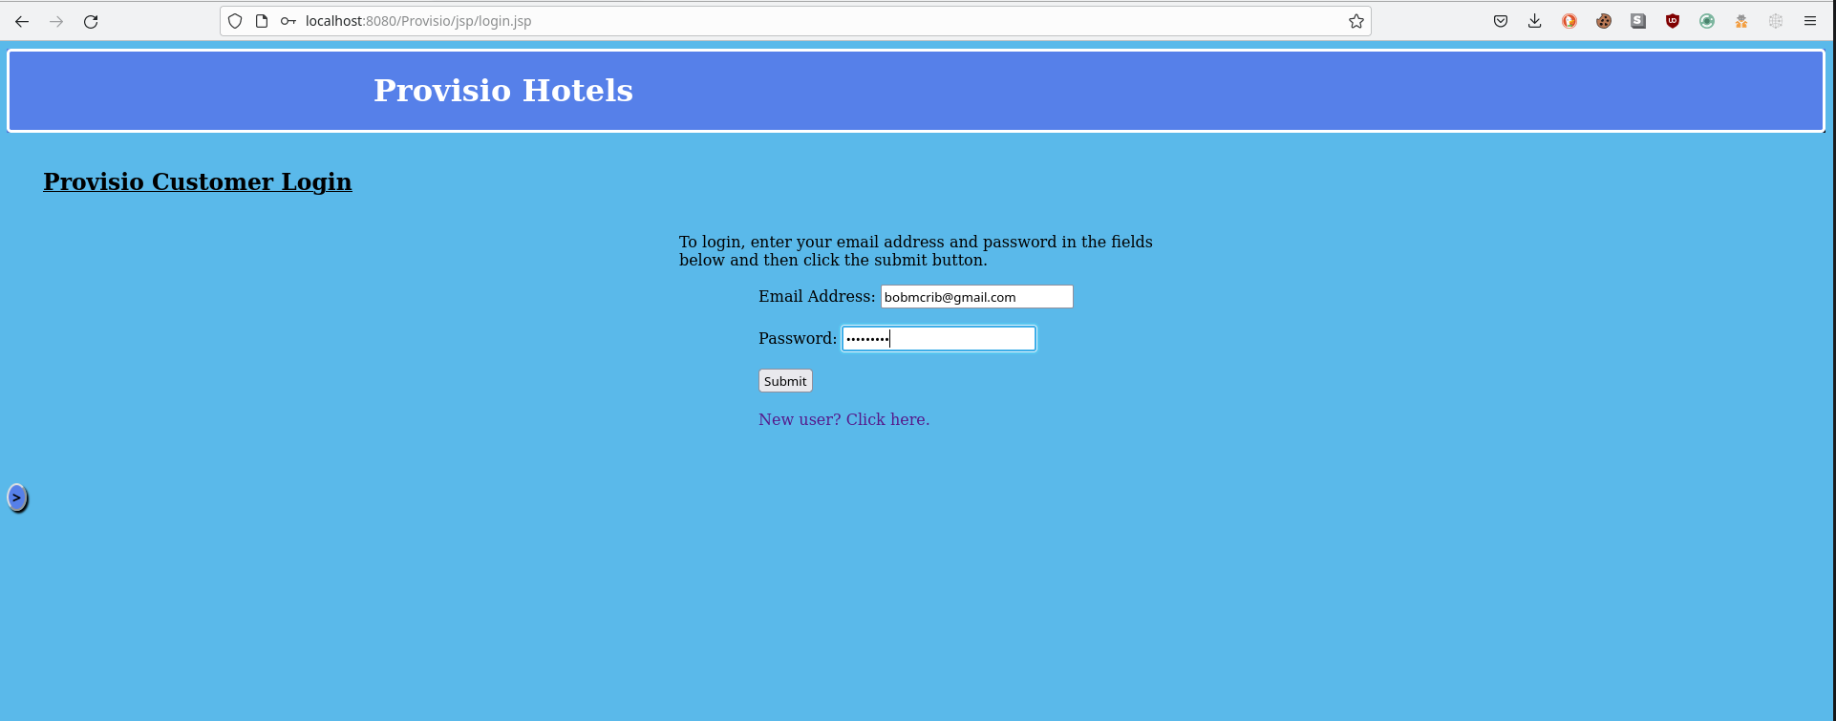

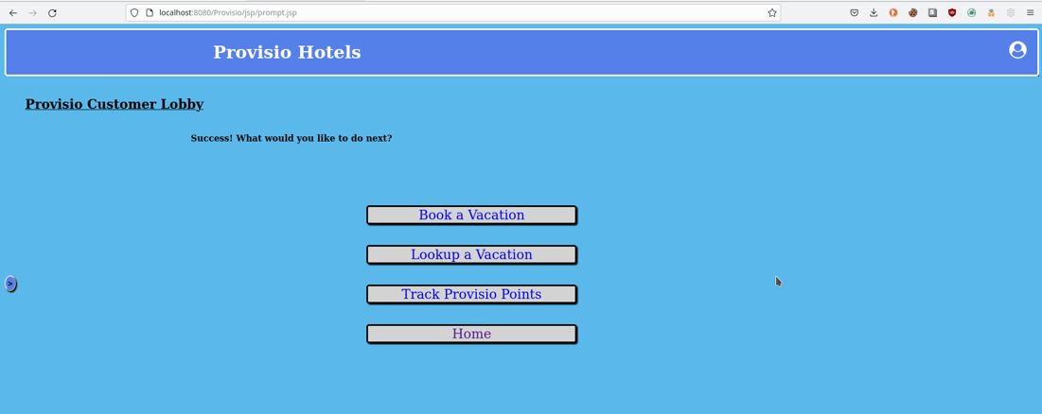

2. Works :



3. Works :  
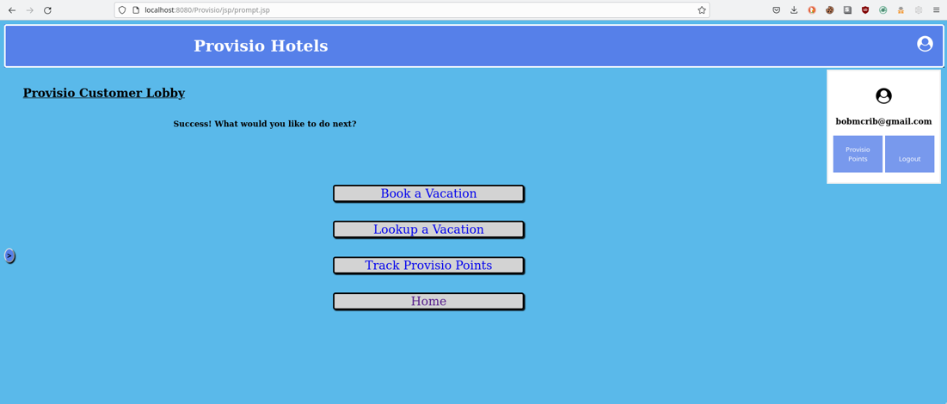

4. Works :

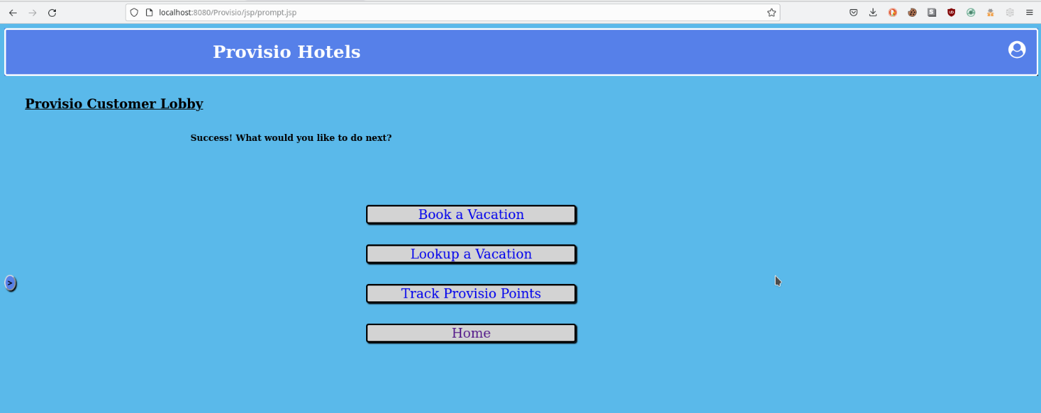  
  
**Caleb’s Comments:** Worked fine for me, no complaints.

|  |  |  |  |  |
| --- | --- | --- | --- | --- |
| Test 4 | **Login Page – Invalid Users** | | | |
|  | **Test Objective:** Verify that invalid users are notified and unable to access. | **Developer:**  **Date tested:** 2022/04/09 | **Peer tester:**  **Date tested:** 2022/04/09 | |
| **Step** | **Action** | **Expected results:** | **Developer pass/fail** | **Tester pass/fail** |
| 1 | Try logging in using bad credentials | Notified of error logging in | yes | yes |
| 2 | Try to submit without entering into fields | Error should be received | yes | yes |
| 3 | Retry with numbers and special chars only for password | Should error out | yes | yes |
| **Comments** | ”Enter comment here”. | | | |

**Test (04/09/2022):**  
1. Works :

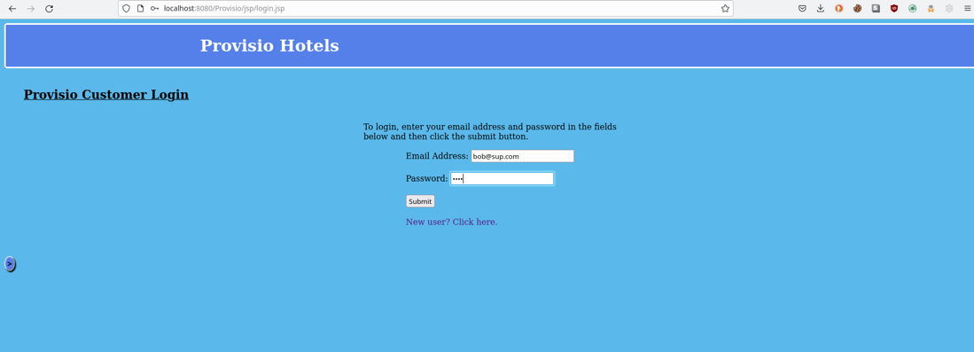  
  
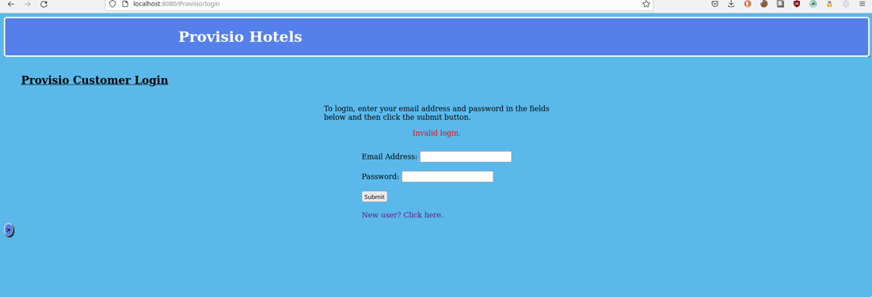

2. Works :



3. Works :   
  
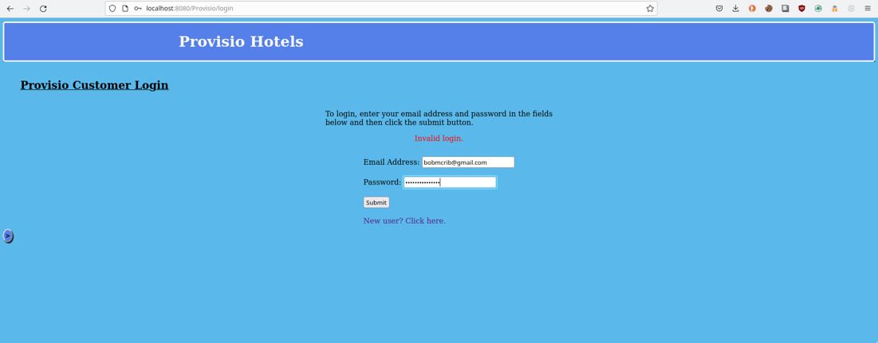  
  
  
  
**Caleb’s Comments:** Worked fine for me, no complaints.

**Camron & Parrish’s Test Plan:**

|  |  |  |  |  |
| --- | --- | --- | --- | --- |
| Test 5 | **Registration Page – Duplicate users** | | | |
|  | **Test Objective:** Confirm users cannot duplicate registration | **Developer:**  **Date tested:** 2022/04/09 | **Peer tester:**  **Date tested:** <2022/04/09> | |
| **Step** | **Action** | **Expected results:** | **Developer pass/fail** | **Tester pass/fail** |
| 1 | Visit Provisio user’s registration tab | Load successfully? | yes | Pass |
| 2 | Register as user according to description method above | Receive successful | yes | Pass |
| 3 | Try to reregister using the same credentials | Receive error | yes | Pass |
| **Comments** | (PWard) - Slight issue when I initially registered where is said password must be 8 characters, but password registered user. | | | |

|  |  |  |  |  |
| --- | --- | --- | --- | --- |
| Test 6 | **Registration Page - Passwords** | | | |
|  | **Test Objective:** Tests user ability to create password by using invalid commands. | **Developer:**  **Date tested:** <yyyy/mm/dd> | **Peer tester:**  **Date tested:** <2022/04/09> | |
| **Step** | **Action** | **Expected results:** | **Developer pass/fail** | **Tester pass/fail** |
| 1 | Create password with fewer than 8 characters | Receive error | yes | Pass |
| 2 | Create password without using an Uppercase letter | Receive error | yes | Pass |
| 3 | Create a password using all Uppercase letters | Receive error | yes | Pass |
| **Comments** | (PWard) Error messages were received for every invalid password type input. | | | |

Parrish Ward’s test 4/9

Test 5 – Step 1

Test 5 – Step 2 & 3

Test 6 – Steps 1/2/3 – Using less than 8 characters, then using all lowercase letters, then using all uppercase letters for password.

